Sports Drinks
Student Name
Institution Affiliation
Date

Sports Drinks
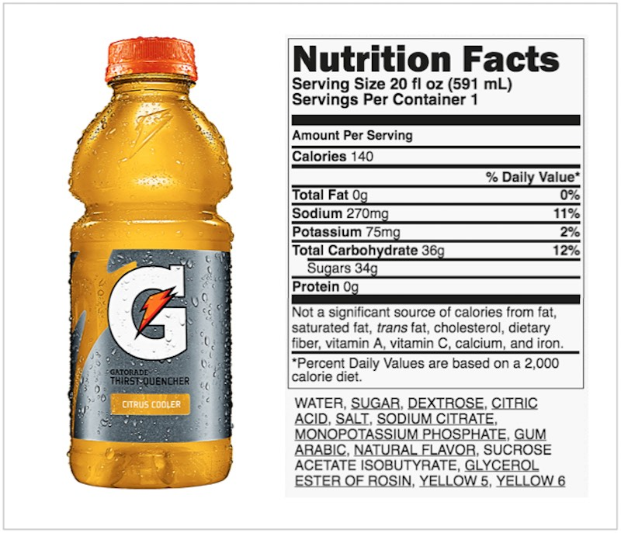

Water is an element of significance for life and maintenance of health through hydration and water balance. Hydration enhances mental and physical performance of people. People can survive up to 50 days without consuming food; however, one can only survive for a few days without water. Athletes consume drinks that help them exercise and work out, which boosts their performance (Orrù et al., 2018). The use of sports drinks is widespread among sportspeople as they replace electrolytes and water in their diet. Due to an increased level of activities, sportspeople lose a lot of water and electrolytes. Hence, the use of sports drinks has been a common practice for them to enhance the replacement of water and electrolytes.
Pros and Cons of Gatorade
The increased incidences of illnesses influenced the development of Gatorade for athletes who engage in strenuous activities. The challenge that was faced by these athletes was due to the loss of fluids and electrolytes while not replacing them (Orrù et al., 2018). Therefore, Gatorade was developed to ensure that the carbohydrates and electrolytes lost through exercise are replaced and hydrating the athletes at the same time. One of the pros of Gatorade is to hydrate and replace the lost electrolytes. The drink provides 270mg of sodium and 75 mg of potassium (Gatorade, 2020). Potassium and sodium are significant in the maintenance of fluid and electrolyte balance in the body. The balance between potassium and sodium ensures that homeostasis is maintained in the body. The renal and other body systems such as integumentary systems use these electrolytes to ensure that there is fluid balance through maintaining excretion through sweating and urine output.
Also, strenuous activities among the athletes lead to loss of energy. Physical activities are linked to consumption large number of calories in the body. Therefore, the use of Gatorade is significant in providing power for athletes. The use of Gatorade offers 140 calories per serving. Moreover, the supply of 36g of carbohydrates is one of the vital elements that ensure that the athletes benefit from energy replacement from the sports drink (Gatorade, 2020).
However, the disadvantage of this drink is that it supplies caloric content in high content. The calories come from the sugar content, which is up to 9% of the sports drink. The presence of increased sugar levels can lead to slow absorption of fluid in the body. Also, the drink does not provide other micronutrients that are significant in the body, such as vitamins, iron, calcium, fiber, and fats. Therefore, the fluids only help in the replacement of energy, electrolytes, and fluids.

Situations when the Sports Drinks are Necessary
There are various situations where sports drinks are necessary. When engaging in physical exercise for over one hour, it is significant to use sports drinks (Orrù et al., 2018). For physical activities that are done for less than one hour, the use of water is necessary; this is because the use of sports drinks leads to the supply of excess calories, which will have adverse impacts on people's health. Also, sports drinks should be consumed when exercise is done in hot weather. In hot weather, sweating occurs excessively, which leads to loss of electrolytes and water in large quantities, which should be replaced to enhance fluid and electrolyte balance. Also, sports drinks should be consumed when engaging in intense exercises. Intense exercise is associated with increased loss of electrolytes and energy, which is significant to be replaced.
Personal Thoughts
I reviewed the pros and cons of sports drinks, and when they should be consumed and preferred water consumption. The use of sports drinks has been suggested for a group of people and various events. The use of sports drinks has been recommended to be advantageous in strenuous activities for more than an hour. The category of people who fall under strenuous and prolonged physical activities are limited. Consumption of sports drinks is associated with adverse health impacts. Water is a significant element to hydrate the body after vigorous exercise. Therefore, water is the best choice for hydration, as it cannot lead to adverse health effects.

References
Gatorade. (2020). Retrieved 11 June 2020, from https://www.gatorade.com/
Orrù, S., Imperlini, E., Nigro, E., Alfieri, A., Cevenini, A., Polito, R., Daniele, A., Buono, P., & Mancini, A. (2018). Role of Functional Beverages on Sports Performance and Recovery. Nutrients, 10(10), 1470. https://doi.org/10.3390/nu10101470

